**Getting Started with Node.js**

Node.js is a framework for building cross platform server side applications in Javascript. It is built on top of [**Google Chrome’s V8 Engine**](https://developers.google.com/v8/), which is a high performance Javascript engine written in C++.

Node.js is **single threaded**. It uses an **event-driven** architecture and is capable of **asynchronous/non-blocking I/O**.

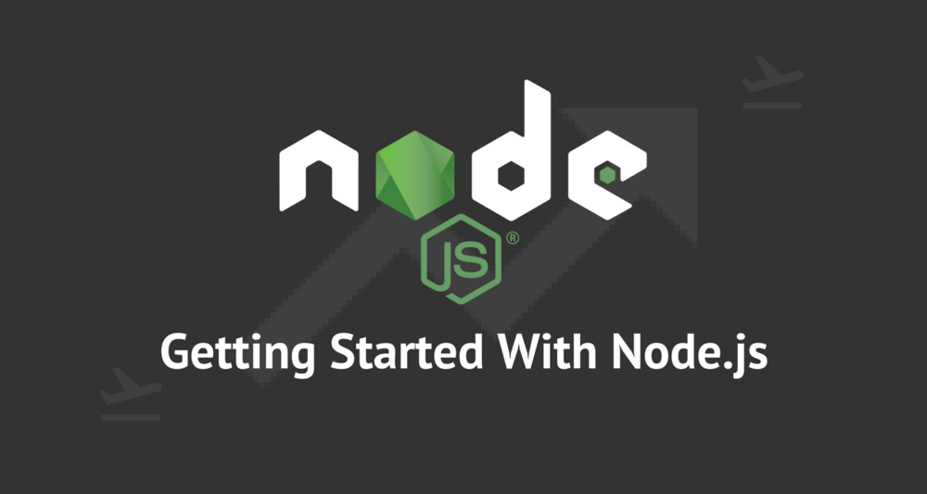

**Prerequisites**

should have a basic understanding of JavaScript. one should have some understanding of other web technologies such as HTML, CSS, AJAX, etc.

**Why node.js**

Node. js is primarily used for non-blocking, event-driven servers, due to its single-threaded nature. It's used for traditional web sites and back-end API services, but was designed with real-time, push-based architectures in mind.

**Features of Node.js**

Asynchronous and Event Driven

Single Threaded but Highly Scalable

No Buffering

Very Fast − Being built on Google Chrome's V8 JavaScript Engine, Node.js library is very fast in code execution.

License − Node.js is released under the MIT license

**Where to Use Node.js?**

Following are the areas where Node.js is proving itself as a perfect technology partner.

I/O bound Applications

Data Streaming Applications

Data Intensive Real-time Applications (DIRT)

JSON APIs based Applications

Single Page Applications